**Bug ID**: 001

**Bug Summary**: New board button is not functional when all boards are completed for "You have completed all boards. Well done!" screen

**Environment/URL**: https://boardlyapp.com

**Operation System**: Windows 8.1, 64

**Version**: Beta version

**Browser**: Chrome

**Submit Date**:  05/09/2021

**Reporter**: Anna Ohanyan

**Steps to Reproduce**:

       1. Open URL

      2. Click on “Login” button

3. Enter email address and click on the “Get magic Link”

4. Click on “My Boards” button

**Expected Result**: New board button should be functional when all boards are completed for "You have

completed all boards. Well done!" screen.

**Actual Result**: New board button is not functional when all boards are completed for "You have completed all boards. Well done!" screen.

**Screenshot/video**: Screenshot is attached

**Severity**: Critical

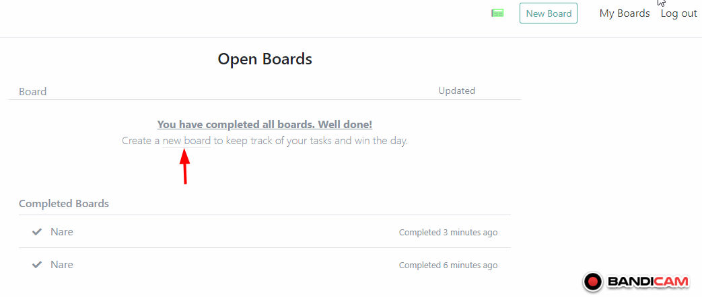

**Bug ID**: 002

**Bug Summary**: Odd +Subtask button present when it is already clicked.

**Environment/URL**: https://boardlyapp.com

**Operation System**: Windows 8.1, 64

**Version**: Beta version

**Browser**: Chrome

**Submit Date**:  05/09/2021

**Reporter**: Anna Ohanyan

**Steps to Reproduce**:

       1. Open URL

      2. Click on “Login” button

3. Enter email address and click on the “Get magic Link”

4. Click on “My Boards” button

5. Click on the task from “TODO” list of active board

**Expected Result**: New board button should be functional when all boards are completed for "You have

completed all boards. Well done!" screen.

**Actual Result**: New board button is not functional when all boards are completed for "You have completed all boards. Well done!" screen.

**Screenshot/video**: Screenshot is attached

**Severity**: Medium

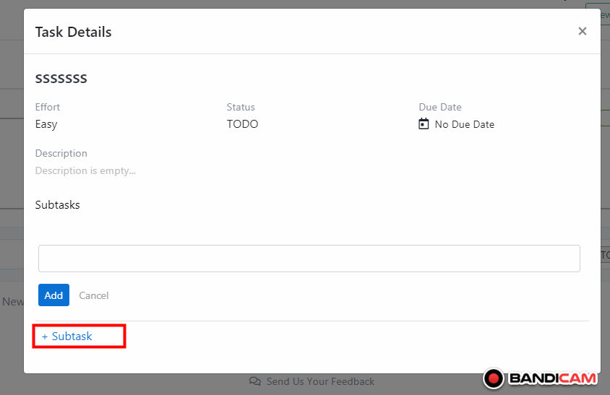

**Bug ID**: 003

**Bug Summary**: "Done" State is not green

**Environment/URL**: https://boardlyapp.com

**Operation System**: Windows 8.1, 64

**Version**: Beta version

**Browser**: Chrome

**Submit Date**:  05/09/2021

**Reporter**: Anna Ohanyan

**Steps to Reproduce**:

       1. Open URL

      2. Click on “Login” button

3. Enter email address and click on the “Get magic Link”

4. Click on “My Boards” button

5. Click on the “Done Tasks” button

**Expected Result**: "Done" State should be green according to counts board.

**Actual Result**: "Done" State is not green.

**Screenshot/video**: Screenshot is attached

**Severity**: Medium

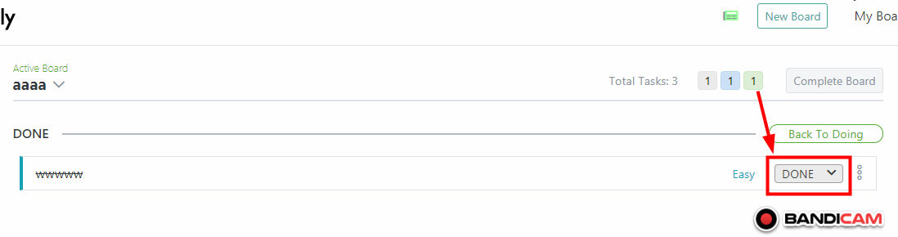

**Bug ID**: 004

**Bug Summary**: When deleting Task the Total number is not updated real-time

**Environment/URL**: https://boardlyapp.com

**Operation System**: Windows 8.1, 64

**Version**: Beta version

**Browser**: Chrome

**Submit Date**:  05/09/2021

**Reporter**: Anna Ohanyan

**Steps to Reproduce**:

       1. Open URL

      2. Click on “Login” button

3. Enter email address and click on the “Get magic Link”

4. Click on “My Boards” button

5. Delete task

**Expected Result**: When deleting Task the Total number should be updated real-time.

**Actual Result**: When deleting Task the Total number is not updated real-time.

**Screenshot/video**: Screenshot is attached

**Notes:** Though when adding new one it is updated real-time.

**Severity**: Critical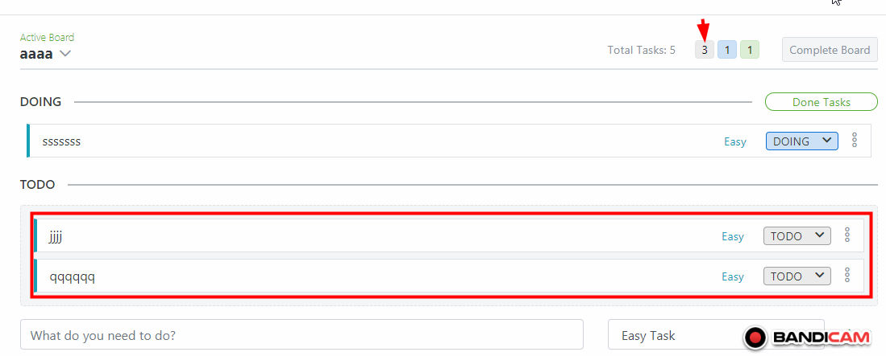

**Bug ID**: 005

**Bug Summary**: Pubic link is still active when disabling the Public Access

**Environment/URL**: https://boardlyapp.com

**Operation System**: Windows 8.1, 64

**Version**: Beta version

**Browser**: Chrome

**Submit Date**:  05/09/2021

**Reporter**: Anna Ohanyan

**Precondition:**

1. The active board is opened

2. The user shared the link

**Steps to Reproduce**:

1. Click on the chevron down icon next to the active board

4. Select “Public access-enabled” from dropdown list

5. Click on the “Disable Public Access” button

6. Check link deactivation.

**Expected Result**: Pubic link should become inactive when disabling the Public Access

**Actual Result**: Pubic link is still active when disabling the Public Access.

**Screenshot/video**: -

**Severity**: Critical